|  |
| --- |
|  |

|  |
| --- |
| Signal Integrity Education |
| Portland State University Capstone Project |
|  |
| **By: Travis Berger and Luis Santiago**  **Corporate Sponsor: Tony Mulienberg Intel**  **Academic Advisor: Dr. James Morris PSU** |
|  |

Acknowledgements

Abstract

Table of Contents

**Introduction**

This project was a collaboration between Intel and Portland State University. Intel developed a validation board called the Education Engagement Electrical Validation Board (E3VB). The purpose of this board was to teach engineering students and members of industry about signal integrity issues through hands on experiments. The goal of this project was to improve upon the E3VB but designing two additional experiments that can be added to the board in a future revision. Intersymbol interference, crosstalk, and proper mixed signal return path techniques were the signal integrity issues were the main focus of these experiments. To best highlight these issues two separate experiment boards were chosen one for ISI and Crosstalk and the other board for the proper mixed signal return path techniques. Due to the chosen audience a requirement for the experiments was to only utilize basic equipment available to electrical engineering students and industry members. This equipment included a function generator, oscilloscope, and a power supply. Knowledge of how to use this equipment is assumed. Both experiments have onboard clocks and have the option of being powered by micro USB or external power supply. Since the intended audience includes college students cost was a factor when designing this experiment, so it was decided that each experiment board could not exceed $100.00 in cost.

**Background**

ISI background

Intersymbol interference is a signal integrity issue that occurs in dispersive channels. Intersymbol interference occurs when   
  
Crosstalk Background

MSG background

**Timeline**

This project started with a projected timeline of ten weeks to deliver the agreed upon deliverables. This time period was broken down into four main phases. The phases were design, implementation, testing, and pass down preparation. Design was allotted three weeks, implementation was allotted one week, testing was allotted three weeks, and pass down preparation was allotted one week. Due to obligations outside of the project each week accounts for roughly thirty – forty man hours per week. Over the course of the project these estimated deadlines shifted around due problems that arose.

**Design**

The problem this project attempted to solve was pretty open ended, so the design phase started with brainstorming possible signal integrity experiments. Two experiments were chosen, mixed signal ground techniques and an experiment dealing with intersymbol interference and crosstalk.   
  
Mixed Signal Return Path Techniques (Solidify name at some point)

This experiment was consists of both digital and analog circuity. The point of this experiment was to highlight signal integrity issues that occur due to improper return paths in mixed signal applications. To best illustrate this the digital portion of the circuit needed to be noisey. The analog portion needed to represent sensitive analog circuity but still be easy and intuitive to use with the constraint that the whole board be less than $100.00. For the digital portion the design consisted of a 10 MHz clock (?) and three Hex inverter packages. Each package contained (6/7?) inverters driving a resistive load. The idea behind this design was the inverters in parallel would cause a big spike when switching. The resitive load was determined to be 1350 Ω because this caused the inverter to drive max current (Add current here). For the analog portion of the circuit a basic NE5532 operation amplifier was chosen. This was due to familiarity with intended audience and flexibility to create several different circuit topologies. Jumpers were used in place of components, which allows the user to select what type of operation the op amp will perform. Figure 1 shows the two different return paths for the digital circuit. Return Path A goes straight back to the power supply. Return Path B goes directly through the analog portion of the board.

Digital Circuity With

Semi-Isolated Ground Plane

Return Path A

Return Path B

Analog Circuity

Source

Isolation

Figure 1: Diagram showing different return paths for mixed signal ground experiment.

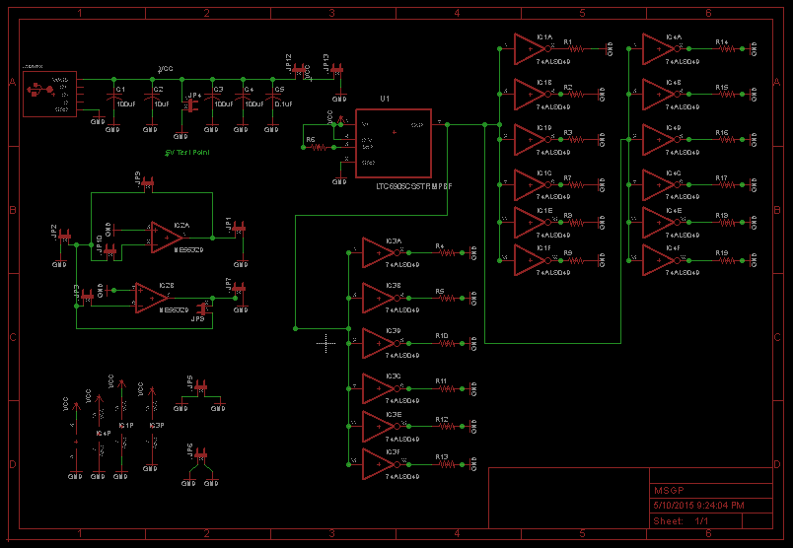

Figure 2: CadSoft EAGLE schematic for mixed signal ground technique experiment.

The schematic was created in CadSoft EAGLE software. Figure 2 shows the schematic for the experiment.

ISI/Crosstalk experiment:

**Implementation**

After the design phase was complete the design was implemented by creating board layouts to have fabricated at OSH Park. CadSoft EAGLE was also used to create the layout for both boards. The layout for the ISI experiment was particularly challenging given the need to route five <insert length> traces with 6 mil of separation between them. This combined with intentionally breaking DRC rules presented some obstacles. Figure 3(a) shows the layout for the mixed signal ground techniques experiment and Figure 3(b) shows the layout for the ISI/Crosstalk experiment.

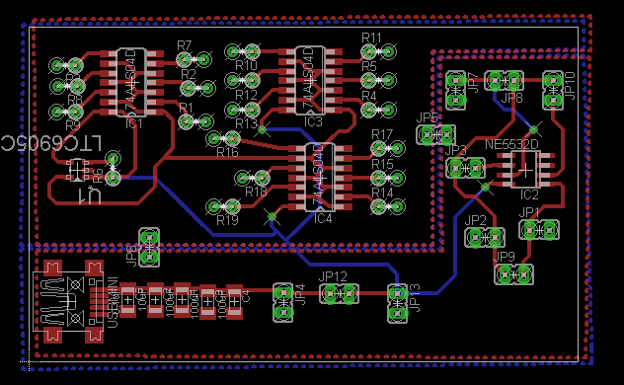

(a)

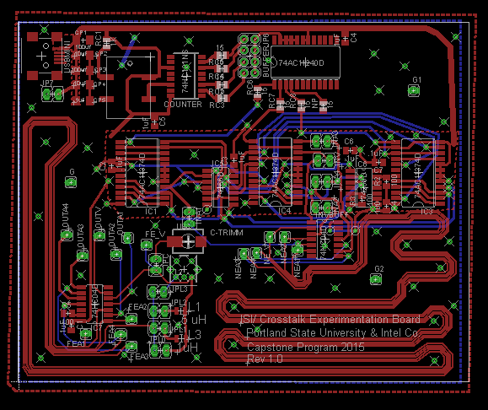

(b)

Figure 3: (a) CadSoft EAGLE layout for the mixed signal ground techniques experiment. (b) CadSoft EAGLE layout for the ISI/Crosstalk experiment.

When the boards came back from OSH Park the majority of the components were placed using solder paste and a reflow oven. All the through hole parts were soldered by hand using a soldering iron.

Parts list

<BOM GOES HERE>

**Testing**

The testing of these experiments was broken down into stages. The first stage of testing was module testing. For module testing each individual module was soldered to a breakout board and tested individually. Once modules were found to be working correctly they were then integrated together for integration testing. In this phase of testing the modules were connected together and tested to determine performance. <rephrase to represent test plan but not like it was actually done>. Unfortunately testing was pushed back due to an unexpected change in resources. This resulted in a few errors slipping by and not being caught until the layouts were already sent to fabrication. On the mixed signal ground techniques experiment the clock was found to work at 3.3 V instead of 5 V and no external resistance was needed to set the divisions. This error couldn’t be fixed on the fabricated board so the clock was left out of this experiment and an external clock was used as proof of concept. On the ISI/Crosstalk experiment the XNOR<double check?> needed a pull up resistor and a capacitor to ground. Another problem that was encountered was the wrong type of mini usb connector was ordered for the power supply. A Mini USB A was ordered which is really hard to find a connector for. Most Mini USB connectors are Mini USB B. To overcome this problem an external power supply was connected to the board.

<Insert pictures of test modules>

**Pass Down Preparation**

Since this project will be carried on by a different group of students and/or engineers it was important to prepare the project to be passed down successfully. This preparation included updating all schematics and layouts to reflect final design, fixing all the errors found during testing, and updating documentation. The main changes to the MSGT experiment were making the board larger, allowing the ability to turn on each individual inverter to see the effects of one two or three inverters on analog signal, updated clock to work with 5 V, and changed the topologies of one of the op amps to allow for more diverse operations. The main changes in the ISI/Crosstalk experiment was to add the pull up resistor and bypass capacitor for the XNOR in the layout. The pass down documentation consisted of setup and instructions for experiments, noticeable design decisions, and improvements that still need to be made to the experiments.

<Include some of the changes in layout?>

**Results**<include measurement images and some comments>

**Conclusion**

The goals of this project were met by designing and implementing a mixed signal ground techniques experiment and a new ISI/Crosstalk experiment. With modifications both experiment boards worked and the team was able to demonstrate these working experiments to the corporate sponsor. The pass down preparation was essential to ensuring that this project will continue with future engineers and students in the future.

Throughout this process many lessons were learned. The first lesson learned was that you can’t possibly plan for everything so your time schedule needs to account for these unplanned surprises. This was seen numerous times throughout the project most prominently in the change of scope in week 9, losing two team members, and a team member coming down with pneumonia. The second lesson learned was not to ship layouts out to the manufacturer until all testing is complete. This was a tough decision for us because we wanted to get the boards back in time to test and document, but ultimately we spent just as much time debugging and correcting the errors then we would have if we stuck to our test plan and sent the boards out a week late. Despite these obstacles the team was able to keep moving forward and made progress on the project. The most important lesson learned by this group was how to fail and keep moving forward. The final team members have a history of doing well in school especially excelling in academic projects. This project while successful did not win any awards at the poster ceremony. This was a hard lesson for the group but an important one because in life you can’t always be the best but you need to stand by your work and be proud of the accomplishments of you peers.

**References**